- Sinteza întrerupătoarelor:
- Ecuații:
        - L1: $D*Vg + \left(1-D\right)*\left(Vg - VC1 - VC2\right)= 0$
        - L2: $D*\left(VC1 - VC2\right)+ \left(1-D\right)*VC1 = 0$
        - C1: $D*\left( - IL2\right)+ \left(1-D\right)*\left(IL1 - IL2\right)= 0$
        - C2: $D*\left(IL2-\frac{VC2}{R}\right)+\left(1-D\right)*\left(IL1-\frac{VC2}{R}\right)=0$
      - Valori medii pentru tensiunile capacitive și curenții inductivi:
        - $VC1=\frac{D*Vg}{1-D^{2}}$
        - $VC2=\frac{Vg}{\left(1-D^{2}\right)}$
        - $IL1=\frac{Vg}{R*{\left(1-D^{2}\right)}^{2}}$
        - $IL2=\frac{Vg}{R*\left(1+D\right)* \left(1-D^{2}\right)}$
      - Expresiile curenților prin SPST-uri și ale tensiunilor pe acestea:
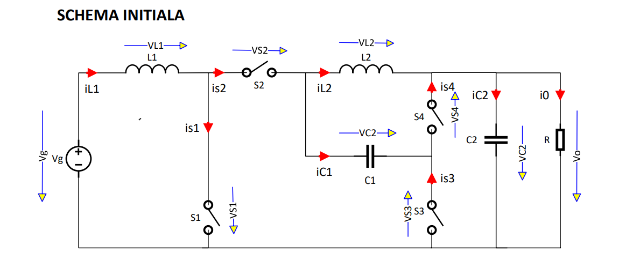
      - Alegerea dispozitivelor fizice:
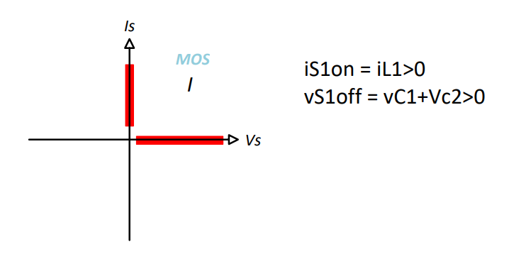

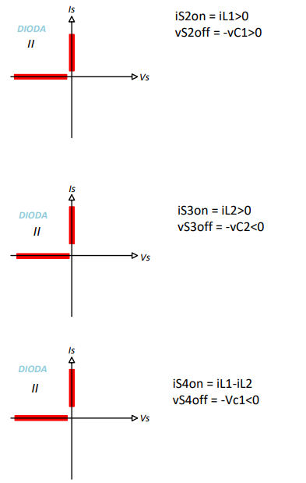

      - Schema finală a convertorului:
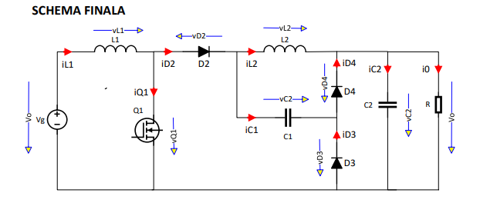
      - Raportul static de conversie ideal:
        - $M =\frac{Vo}{Vg}$
        - $M = n*\frac{D}{1-D}$
      - Reprezentarea grafică a lui M(D):
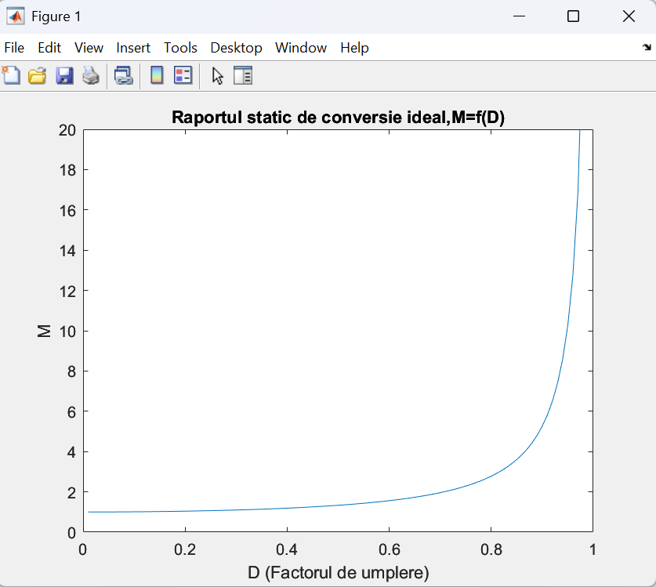

- CUK cu izolare galvanică, cazul ideal:
      - Ecuații:
          - $v1 =\frac{v2}{n}$
          - $i1 + n*i2 = 0$
        - L1: $D*Vg + \left(1-D\right)*\left(Vg - VC1a -\frac{VC1b}{n}\right)= 0$
        - L2: $D*\left(VC1b - VC2 + n*VC1a\right)+ \left(1-D\right)*\left( - VC2\right)= 0$
        - LM: $D*\left( - VC1a\right)+ \left(1-D\right)*\left(\frac{VC1b}{n}\right)= 0$
        - C1a: $D*\left(ILM - n*IL2\right)+ \left(1-D\right)*IL1 = 0$
        - C1b: $D*\left( - IL2\right)+ \left(1-D\right)*\left(\frac{IL1}{n}-\frac{ILM}{n}\right)= 0$
        - C2: $D*\left(IL2 -\frac{VC2}{R}\right)+ \left(1-D\right)*\left(IL2 -\frac{VC2}{R}\right)= 0$
      - Valori medii pentru tensiunile capacitive și curenții inductivi:
        - $VC1a = Vg$
        - $VC1b =\frac{n*D*Vg}{1-D}$
        - $VC2 =\frac{n*D*Vg}{1-D}$
        - $IL1 = {\left(\frac{n*D}{1-D}\right)}^{2}*\frac{Vg}{R}$
        - $IL2 =\left(\frac{Vg}{R}\right)*\frac{n*D}{1-D}$
        - $ILM = 0$
      - Schema convertorului cu transformator ideal:
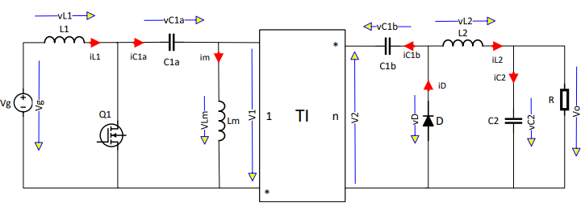

      - Raportul static de conversie ideal:
        - $M =\frac{Vo}{Vg}$
        - $M = n*\frac{D}{1-D}$

      - Dependența Mideal=f(D) cu n parametru:

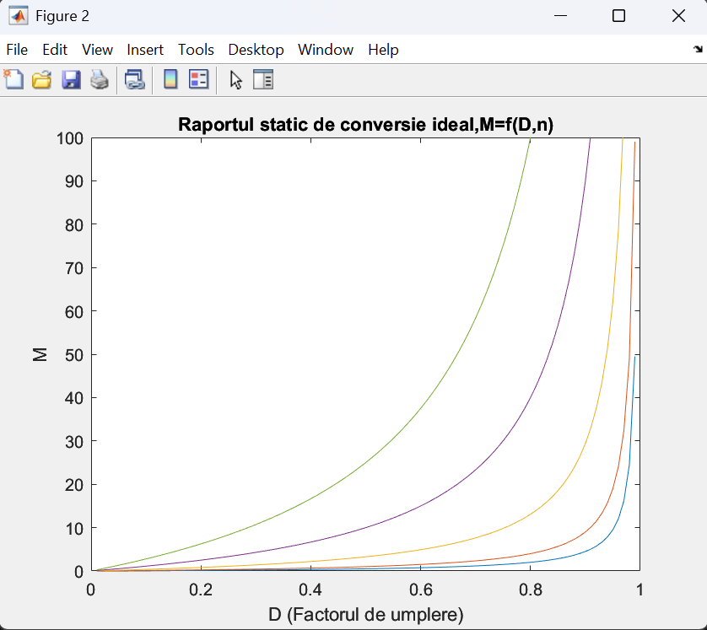

- Graficele formelor de undă:
    - Convertor pătratic:
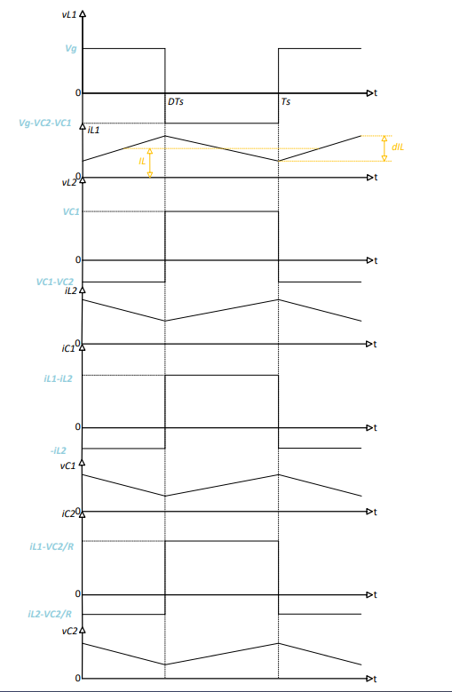
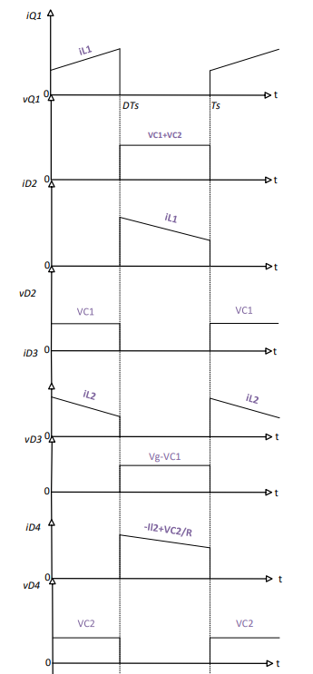

    - CUK cu izolare:
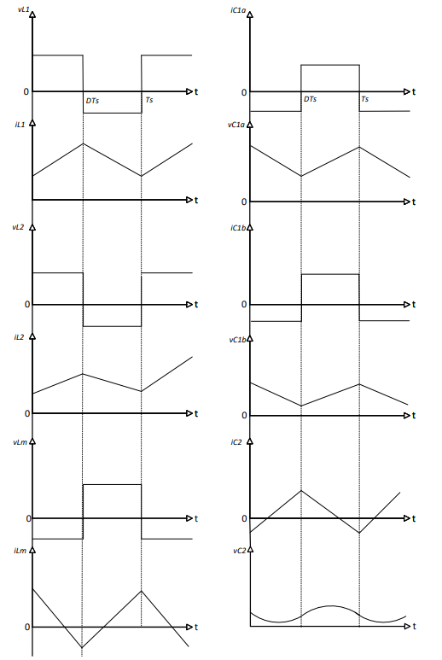
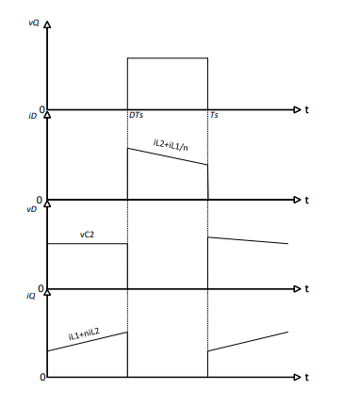
- Pulsații:
    - Convertor pătratic:
      - $∆IL1 = D*\frac{\left|VL1on\right|}{L1*fs}= D*\frac{Vg}{L1*fs}$
      - $∆IL2 = \left(1-D\right)*\frac{\left|VL2off\right|}{L2*fs}= \left(1-D\right)*\frac{VC1}{L2*fs}= \frac{D*Vg}{L2*fs*\left(1+D\right)}$
      - $∆VC1=D*\frac{\left|IC1on\right|}{C1*fs}= D*\frac{IL2}{C1*fs}= \frac{D*Vg}{C1*R*fs*\left(1-D^{2}\right)*\left(1+D\right)}$
      - $∆VC2=D*\frac{\left|IC2on\right|}{C2*fs}=\frac{D^{2}*Vg}{R*C2*fs*\left(1-D\right)*{\left(1+D\right)}^{2}}$
    - CUK cu izolare:
      - $∆IL1 = D*\frac{\left|VL1on\right|}{L1*fs}= \frac{D*Vg}{L1*fs}$
      - $∆IL2=\left(1-D\right)*\frac{\left|VL2off\right|}{L2*fs}=\left(1-D\right)*\frac{\left|-VC2\right|}{L2*fs}= n*\frac{D*Vg}{L2*fs}$
      - $∆ILM = D*\frac{\left|VLMon\right|}{LM*fs}= \frac{D*Vg}{LM*fs}$
      - $∆VC1a=\left(1-D\right)*\frac{\left|IC1aoff\right|}{C1a*fs}=\left(1-D\right)*\frac{IL1}{C1a*fs}= n^{2}*\frac{D^{2}*Vg}{\left(1-D\right)*C1a*fs*R}$
      - $∆VC1b=D*\frac{\left|IC1bon\right|}{C1b*fs}= D*\frac{\left|-IL2\right|}{C1b*fs}= n*\frac{D^{2}*Vg}{\left(1-D\right)*C1b*fs*R}$
      - $∆VC2 = D*\frac{\left|IC2on\right|}{C2*fs}=\frac{∆IL2}{8*C2*fs}=n*\frac{D*Vg}{8*L2*C2*fs^{2}}$
- Solicitarile semiconductorarelor:
    - Convertor pătratic:
$$I1=IL1+\frac{1}{2}*dIL1$$
$$I2=IL1-\frac{1}{2}*dIL1$$
$$Uk=\frac{1}{3}*\left(I1^{2}+I1*I2+I2^{2}\right)$$
$$RMS=\sqrt{Dk*Uk}$$
        - $IQ = D*IL1 =\frac{D*Vg}{R*{\left(1 - D^{2}\right)}^{2}}$
        - $IQRMS = \sqrt{D}*IL1 =\frac{\sqrt{D}*Vg}{R*{\left(1 - D^{2}\right)}^{2}}$
        - $IQ1RMS_{exact} =\sqrt{D*Uk}$
=$\frac{\sqrt{3}*\sqrt{\left(\frac{D*Vg^{2}*\left(D^{10}*R^{2}- 4*D^{8}*R^{2}+ 6*D^{6}*R^{2}- 4*D^{4}*R^{2}+ D^{2}*R^{2}+ 12*L1^{2}*fs^{2}\right)}{L1^{2}*R^{2}*fs^{2}*{\left(D^{2}- 1\right)}^{4}}\right)}}{6}$
        - $ID2 = \left(1 - D\right)*IL1 = \left(1 - D\right)*\frac{Vg}{R*{\left(1 - D^{2}\right)}^{2}}$
        - $ID2RMS = \sqrt{1-D}*IL1 =\frac{Vg*\sqrt{1-D}}{R*{\left(1 - D^{2}\right)}^{2}}$
        - $ID2RMS_{exact} = \sqrt{\left(1-D\right)*Uk}=\frac{\sqrt{3}*\sqrt{\frac{Vg^{2}*\left(1-D \right)*\left(D^{10}*R^{2}- 4*D^{8}*R^{2}+ 6*D^{6}*R^{2}- 4*D^{4}*R^{2}+ D^{2}*R^{2}+ 12*L1^{2}*fs^{2}\right)}{L1^{2}*R^{2}*fs^{2}*{\left(D^{2}- 1\right)}^{4}}}}{6}$
        - $ID3 = D*IL2 = \frac{\sqrt{D}*Vg}{R*\left(1+D\right)*\left(1-D^{2}\right)}$
        - $ID3RMS =\sqrt{D} *IL2= \frac{\sqrt{D}*Vg}{R*\left(1+D\right)*\left(1-D^{2}\right)}$
        - $ID3RMS_{exact} = \sqrt{D*Uk}$=
            - $\sqrt{3}*\sqrt{\frac{D*Vg^{2}*\left(D^{10}*R^{2}- 4*D^{8}*R^{2}+ 6*D^{6}*R^{2}- 4*D^{4}*R^{2}+ D^{2}*R^{2}+ 12*L1^{2}*fs^{2}\right)}{L1^{2}*R^{}*fs^{2}*{\left(D^{2}- 1\right)}^{4}}}$
        - $ID4 = \left(1 - D\right)*\left(IL1 - IL2\right)=\frac{D*Vg}{R*\left(1-D\right)*{\left(1+D\right)}^{2}}$
        - $ID4RMS = \sqrt{1-D}*\left(IL1 - IL2\right)=\frac{\sqrt{1-D}*Vg}{R*\left(1-D\right)*{\left(1+D\right)}^{2}}$
        - $ID4RMS_{exact}=\sqrt{\left(1-D\right)*Uk}$=
          - $\sqrt{3}*\sqrt{\frac{Vg^{2}*\left(1-D\right)*\left(D^{10}*R^{2}- 4*D^{8}*R^{2}+ 6*D^{6}*R^{2}- 4*D^{4}*R^{2}+ D^{2}*R^{2}+ 12*L1^{2}*fs^{2}\right)}{L1^{2}*R^{2}*fs^{2}*{\left(D^{2}- 1\right)}^{4}}}$

    - CUK cu izolare:
        - $IQ = D*\left(IL1 + n*IL2\right)=n^{2}*\frac{D^{2}*Vg}{R*{\left(1 - D\right)}^{2}}$
        - $IQRMS = \sqrt{D}*\left(IL1 + n*IL2\right)=n^{2}*\frac{\sqrt[3]{D}*Vg}{R*{\left(1 - D\right)}^{2}}$
- $IQRMS_{exact} =\sqrt{D*Uk}$
  - $\frac{\sqrt{3}*\sqrt{\frac{D^{3}*Vg^{2}*\left(D^{4}*R^{2}- 4*D^{3}*R^{2}+ 12*D^{2}*L1^{2}*fs^{2}*n^{4}+ 6*D^{2}*R^{2}- 4*D*R^{2}+ R^{2}\right)}{L1^{2}*R^{2}*fs^{2}*{\left(1-D\right)}^{4}}}}{6}$
        - $ID = \left(1 - D\right)*\left(IL2+\frac{IL1}{n}\right)=n*\frac{D*Vg}{R*(1-D)}$
        - $IDRMS = \sqrt{1-D}*\left( IL2+\frac{IL1}{n}\right)= n*\frac{D*Vg}{R*\sqrt{{\left(1-D\right)}^{3}}}$
- $IDRMS_{exact}=\sqrt{\left(1-D\right)*Uk}$
  - $\frac{√3*\sqrt{\frac{D^{2}*Vg^{2}*\left(D^{4}*R^{2}- 4*D^{3}*R^{2}+ 12*D^{2}*L1^{2}*fs^{2}*n^{4}+ 6*D^{2}*R^{2}- 4*D*R^{2}+ R^{2}\right)}{L1^{2}*R^{2}*fs^{2}*{\left(D - 1\right)}^{3}}}}{6}$
- Condiția de functionare CCM și neconditionat CCM:
    - Convertor pătratic:
      - Condiția de funcționare CCM:
        - $id2 min⁡ ≥ 0$
$$IL1 - \left(\frac{1}{2}\right)*∆IL1 ≥ 0 → IL1 ≥ \left(\frac{1}{2}\right)*∆IL1$$
$$2*L1*\frac{fs}{R}≥ D*\left(1 - D^{2}\right)$$

        - $id3 min⁡ ≥ 0$
$$IL2 - \left(\frac{1}{2}\right)*∆IL2 ≥ 0 → IL2 ≥ \left(\frac{1}{2}\right)*∆IL2$$
$$2*L2*\frac{fs}{R}≥ D*\left(1 - D^{2}\right)$$
        - $id4 min⁡ ≥ 0$
$$IL1 - IL2 - \left(\frac{1}{2}\right)*\left(∆IL1 - ∆IL2\right)≥ 0$$
$IL1 - IL2 ≥ \left(\frac{1}{2}\right)*\left(∆IL1 - ∆IL2\right)$
$$\frac{2*L1*L2*fs}{R*\left(L2*\left(1+D\right)+ L1\right)}≥ \left(1+D\right)*{\left(1-D\right)}^{2}$$
      - Necondiționat CCM:
              - $2*L1*\frac{fs}{R}≥ max⁡\{ D\left(1 - D^{2}\right)$ }
$$2*L1*\frac{fs}{R}= K ≥ Kcritic$$
$$q\left(D\right)= D*\left(1 - D^{2}\right)= D - D^{3}$$
→ $q΄\left(D\right)= - 3*D^{2}+1$
$$D1 = -\frac{\sqrt{3}}{3}→nu convine; D2 =\frac{\sqrt{3}}{3}→ D =\frac{\sqrt{3}}{3};$$
$$2*L1*\frac{fs}{R} ≥ 2*\frac{\sqrt{3}}{9}→L1*\frac{fs}{R}≥\frac{\sqrt{3}}{9}$$
$$Pentru D =\frac{\sqrt{3}}{3}convertorul pătratic funcționează necondiționat CCM.$$
              - $2*L2*\frac{fs}{R}≥max⁡\{ D\left(1 - D^{2}\right)$ }
$$2*L2*\frac{fs}{R}= K ≥ Kcritic$$
$$q\left(D\right)= D*\left(1 - D^{2}\right)= D - D^{3}$$
$$q΄\left(D\right)= - 3*D^{2}+ 1$$
$$Pentru D =\frac{\sqrt{3}}{3}convertorul pătratic funcționează necondiționat CCM.$$
              - Id4min
$$\frac{2*L1*L2*fs}{R*\left(L2*\left(1+D\right)+ L1\right)}≥\max\left\{ \left(1+D\right)*{\left(1-D\right)}^{2}\right\}$$

$$\frac{2*L1*L2*fs}{R*\left(L2*\left(1+D\right)+ L1\right)}≥1$$
    - CUK cu izolare:
      - Condiția de funcționare CCM:
        - idmin ≥ 0
$$IL2 +\frac{IL1}{n}-\frac{∆IL2}{2}- \frac{∆IL1}{2*n}≥ 0$$
$$2*fs*\frac{L1*\frac{L2}{n^{2}*L1 + L2}}{R}≥\frac{{\left(1 - D\right)}^{2}}{n^{2}}$$
      - Necondiționat CCM:
$$2*fs*\frac{L1*\frac{L2}{n^{2}*L1 + L2}}{R}≥\frac{1}{n^{2}}$$

- Dimensionarea elementelor reactive:
    - Convertor pătratic:
        - L1: $∆IL1 ≤\frac{IL1}{4}→ L1 =\frac{4*Vo^{2}*D*{\left(1 - D^{2}\right)}^{2}}{fs*Po}$
        - L2: $∆IL2 ≤\frac{IL2}{4}→ L2 =\frac{4*Vo^{2}*D*\left(1 - D^{2}\right)}{fs*Po}$
        - C1: $∆VC1 ≤\frac{VC1}{10}→ C1 = 10*\frac{Po}{fs*Vo^{2}*\left(1 + D\right)}$
        - C2: $∆VC2 ≤ ∆Vosp → C2 = \frac{D^{2}*Vg}{R*fs*∆Vosp*\left(1 - D\right)*{\left(1 + D\right)}^{2}}$
    - CUK cu izolare:
        - L1: $∆IL1 ≤\frac{IL1}{4}→ L1 =\frac{4*Vo^{2}*{\left(1 - D\right)}^{2}}{fs*D*Po*n^{2}}$
        - L2: $∆IL2 ≤\frac{IL2}{4}→ L2 =\frac{4*Vo^{2}*\left(1 - D\right)}{fs*Po}$
        - LM: $LM = AL*N^{2}; N ≥ D*\frac{Vg}{2*AL*l*fs*Hmax}; ∆ILM = 2*ILMmax;$
$$ILMmax = N*D*\frac{Vg}{2*LM*l*fs}; Hmax,l,AL→catalog; n=\frac{N2}{N1};$$
        - C1a: $∆VC1a ≤\frac{VC1a}{10}→ C1a = 10*n^{2}*\frac{Po*D^{2}}{fs*Vo^{2}*\left(1 - D\right)}$
        - C1b: $∆VC1b ≤\frac{VC1b}{10}→ C1b = 10*\frac{D*Po}{fs*Vo^{2}}$
        - C2: $∆VC2 ≤ ∆Vosp → C2 = n*\frac{D*Vg}{8*L2*fs^{2}*∆Vosp}$

- Schema de simulare, comparație Matlab - Caspoc:
    - Convertor pătratic:

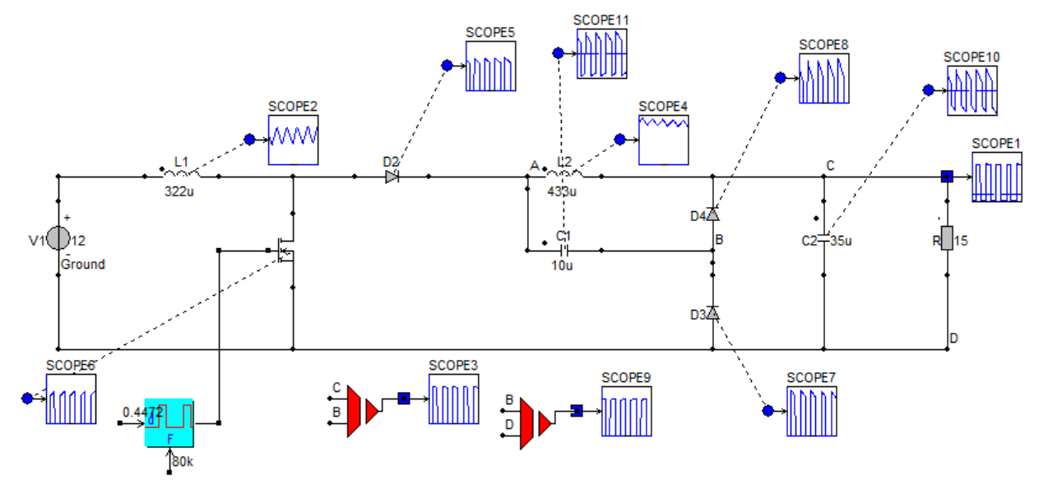

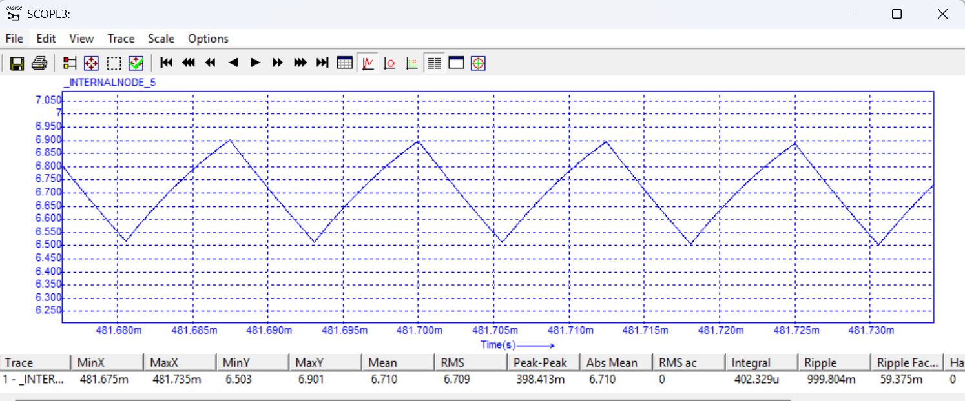
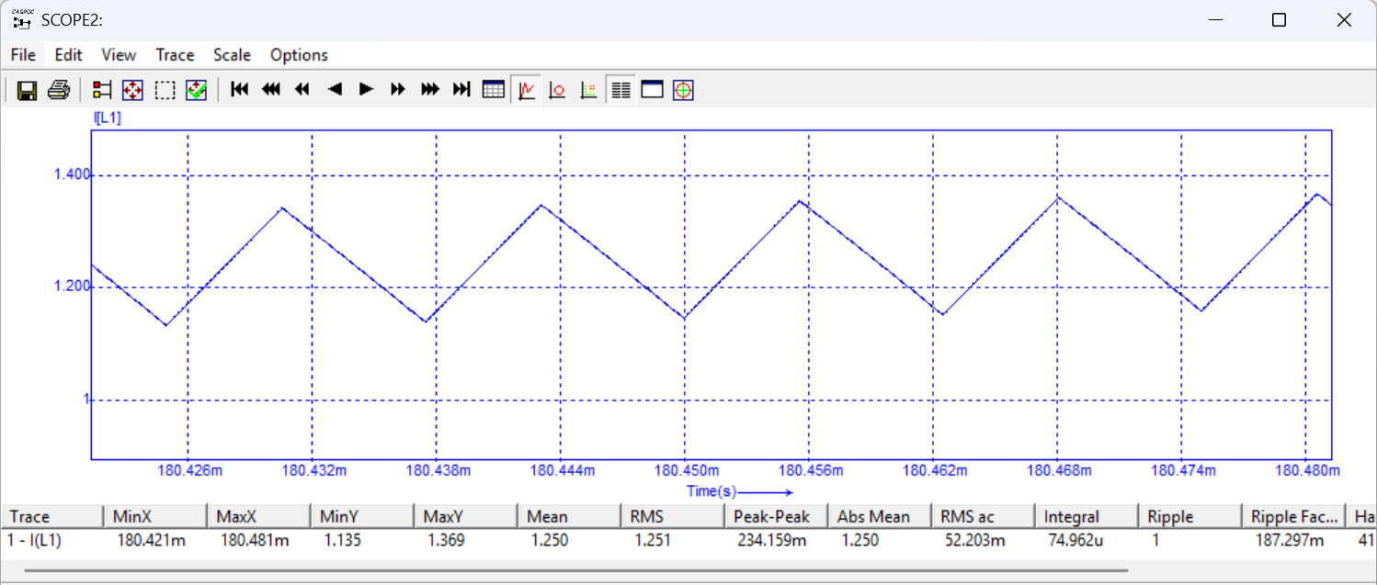

- Comparație Caspoc-Matlab:
 | Caspoc | Matlab
IL1 [A] | 1.206 | 1
IL2 [A] | 0.6914 | 0.691
VC1 [V] | 6.709 | 6.7082
VC2 [V] | 14.987 | 15
IQrms [A] | 0,8051 | 0.8359
ID2 [A] | 0.7106 | 0.6910
ID3 [A] | 0,3038 | 0.3090
ID4 [A] | 0.3026 | 0.3090
IQ [A] | 0,5248 | 0.5590

    - CUK cu izolare:
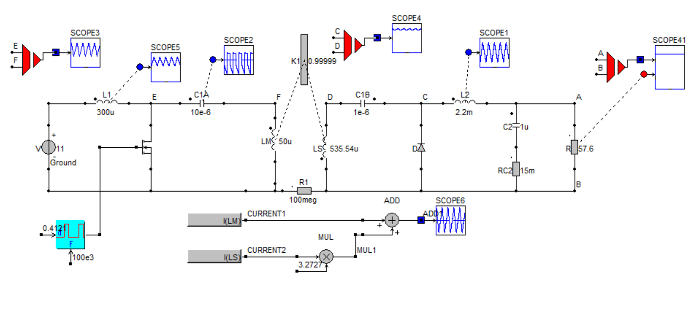
- Curent de magnetizare:
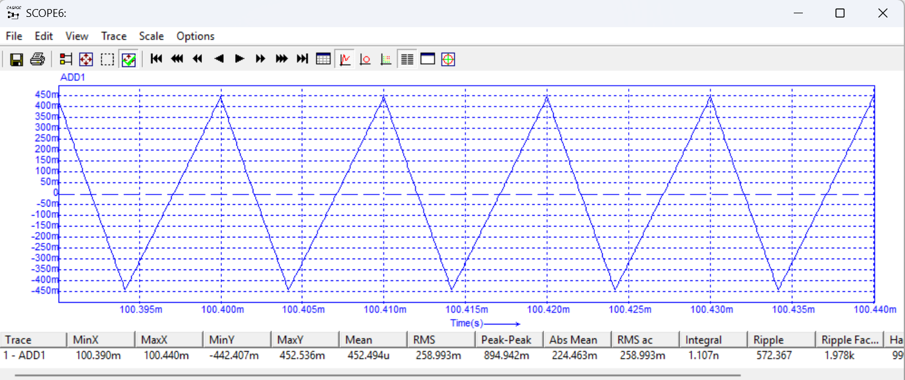
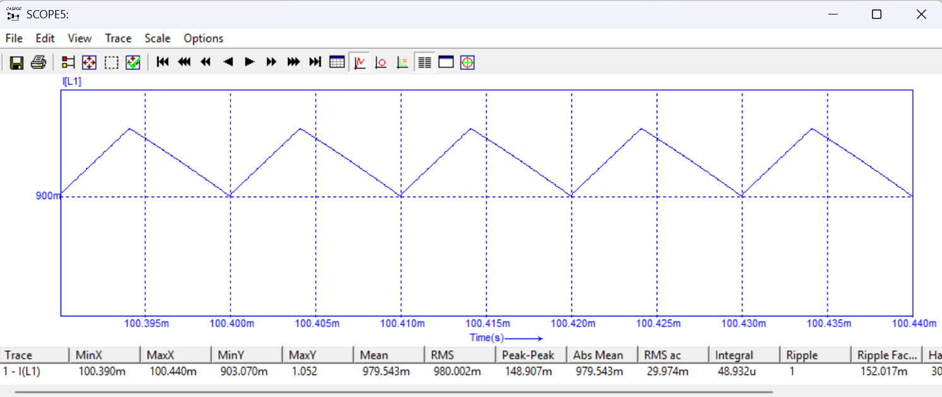
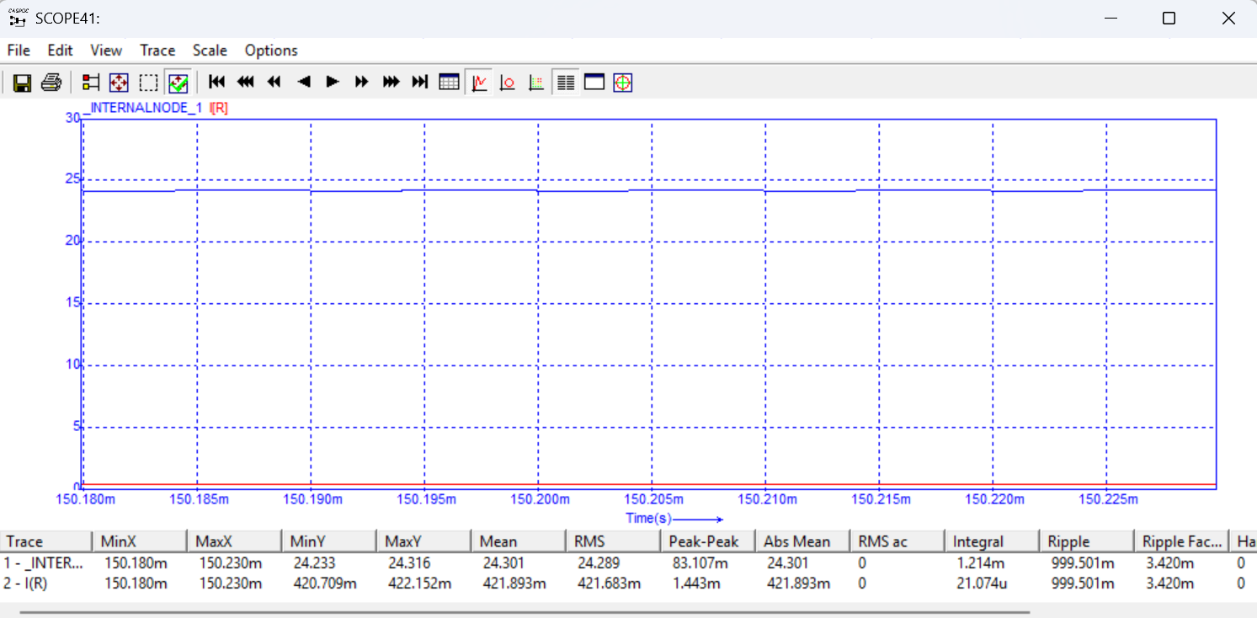

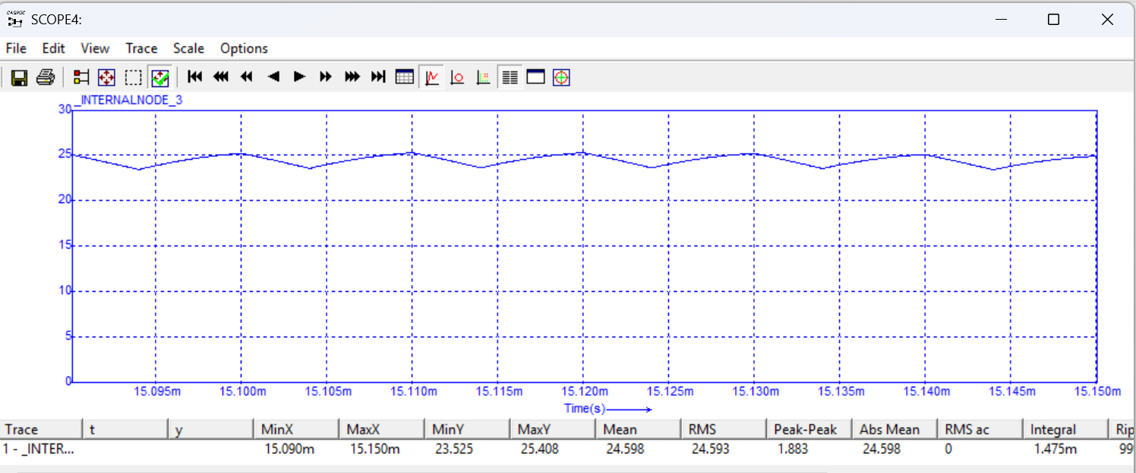

- Comparație Caspoc-Matlab:
 | Caspoc | Matlab
IL1[A] | 0.9084 | 0.9091
IL2 [A] | 0.4169 | 0.4167
VC1a [V] | 11.013 | 11
VC1b [V] | 23.976 | 23.9998
VC2 [V] | 24.009 | 23.999
dVC2 [mV] | 83 | 81,8

- Comparatia elementelor semiconductoare primite cu cele din foile de catalog:
    - Convertor pătratic:
Parametru: | Imediu | Irms | Irms  exact | Icatalog | Vmediu | Vcatalog | Status
Q | 559mA | 836mA | 836,9mA | 6.5A | 12V | 200V | OK
D2 | 691mA | 929,4mA | 930,4mA | 10A | 6,709V | 100V | OK
D3 | 309mA | 462,1mA | 462,6mA | 10A | 15V | 100V | OK
D4 | 309mA | 415,6mA | 416,2mA | 10A | 15V | 100V | OK

    - CUK cu izolare:
Parametru: | Imediu | Irms | Irms  exact | Icatalog | Vmediu | Vcatalog | Status
Q | 981,7mA | 1.536A | 1.542A | 6.5A | 11V | 200V | OK
D | 421,1mA | 556,2mA | 556,6mA | 10A | 24V | 100V | OK

- Punctul de funcționare ales, factorul de umplere calculat, rezultatele simulării:
    - Convertor pătratic:
          - Am ales Vgmax, Vomax.
          - D=solve(VC2-Vo, D),
          - syms z
          - a=simplify(R^2*VD2 - R^2*Vg + R^2*Vo - R^2*VD2*z^2+ R^2*VD2*z^3- R^2*VD3*z^2- R^2*VD3*z^3- R^2*VD4*z^2+ R^2*VD3*z^4- R^2*VD4*z^3+ R^2*VD4*z^4+ R^2*Vg*z^2- 2*R^2*Vo*z^2+ R^2*Vo*z^4+ R*RC2*VD2 - R*RC2*Vg + R*RC2*Vo - R^2*VD2*z + R^2*VD3*z + R^2*VD4*z - R*RC2*VD2*z^2+ R*RC2*VD2*z^3- R*RC2*VD3*z^2- R*RC2*VD3*z^3- R*RC2*VD4*z^2+ R*RC2*VD3*z^4- R*RC2*VD4*z^3+ R*RC2*VD4*z^4+ R*RC2*Vg*z^2- 2*R*RC2*Vo*z^2+ R*RC2*Vo*z^3- R*RC2*VD2*z + R*RC2*VD3*z + R*RC2*VD4*z + R*Ron*Vo*z + RC2*Ron*Vo*z)
          - p=collect(a,z),
          - a4=(R^2*VD3 + R^2*VD4 + R^2*Vo + R*RC2*VD3 + R*RC2*VD4);
a3=(R^2*VD2 - R^2*VD3 - R^2*VD4 + R*RC2*VD2 - R*RC2*VD3 - R*RC2*VD4 + R*RC2*Vo);
a2=(R^2*Vg - R^2*VD3 - R^2*VD4 - R^2*VD2 - 2*R^2*Vo - R*RC2*VD2 - R*RC2*VD3 - R*RC2*VD4 + R*RC2*Vg - 2*R*RC2*Vo);
a1=(R^2*VD3 - R^2*VD2 + R^2*VD4 - R*RC2*VD2 + R*RC2*VD3 + R*RC2*VD4 + R*Ron*Vo + RC2*Ron*Vo);
a0=(R^2*VD2 - R^2*Vg + R^2*Vo + R*RC2*VD2 - R*RC2*Vg + R*RC2*Vo);
          - D=roots([a4 a3 a2 a1 a0])
          - D= 0.5012

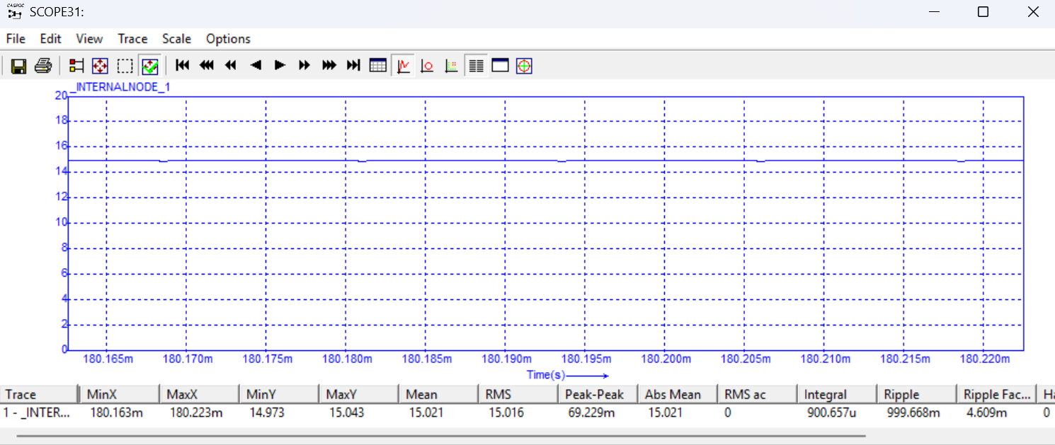

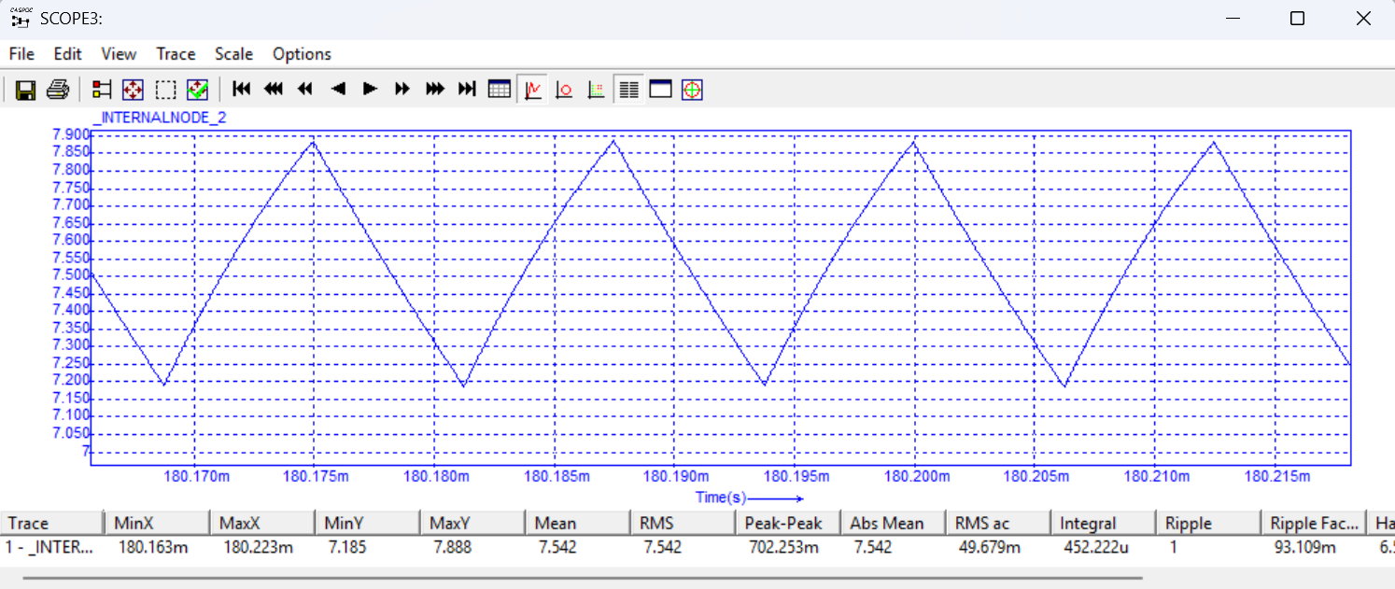

    - CUK cu izolare:
          - $Am ales Vgmax, Vomax.$
          - $D=solve\left(VC2-Vo, D\right),$
- $D2=0.9875$ %nu convine
- $D1= 0.4121$
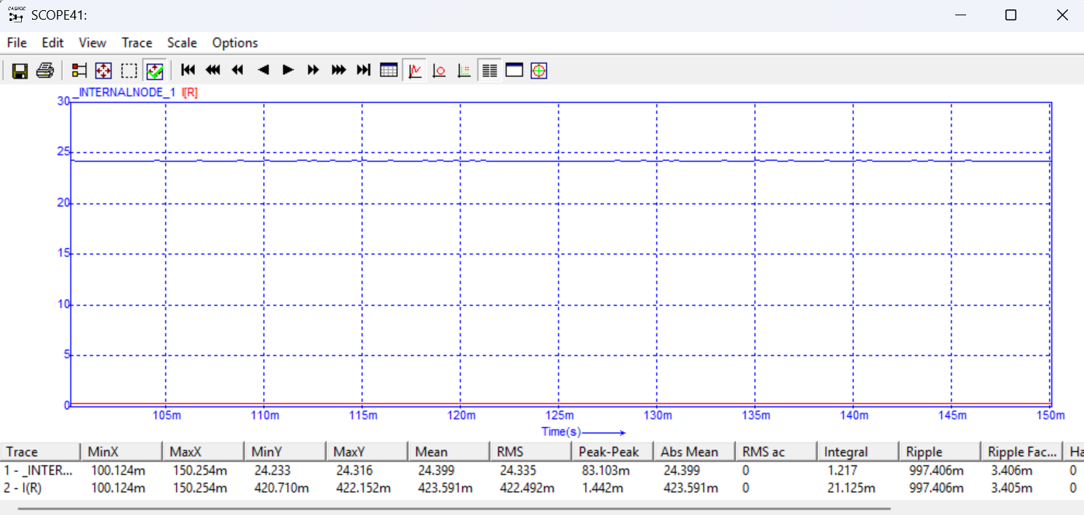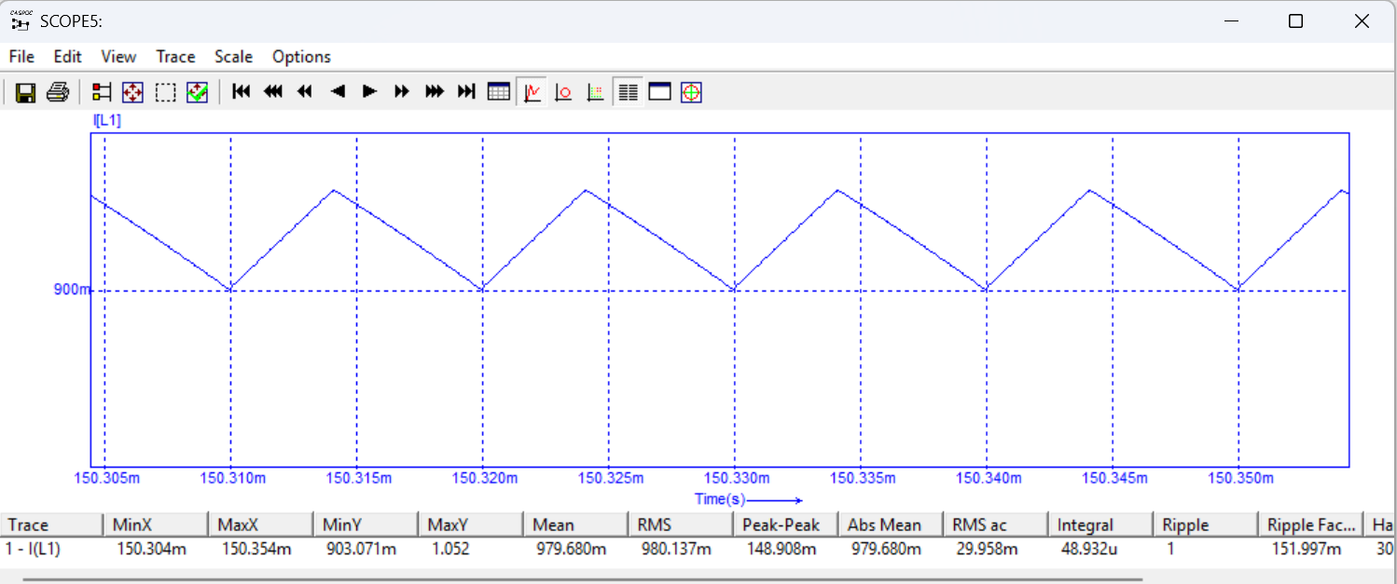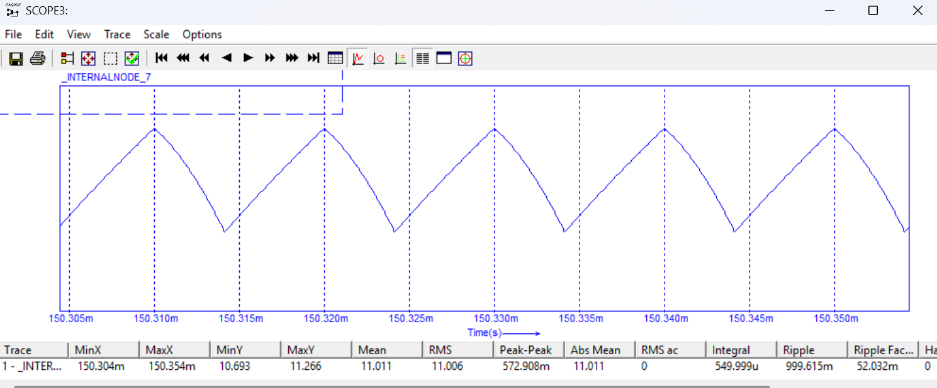

- Dependența M=f(D):
    - Convertor pătratic:
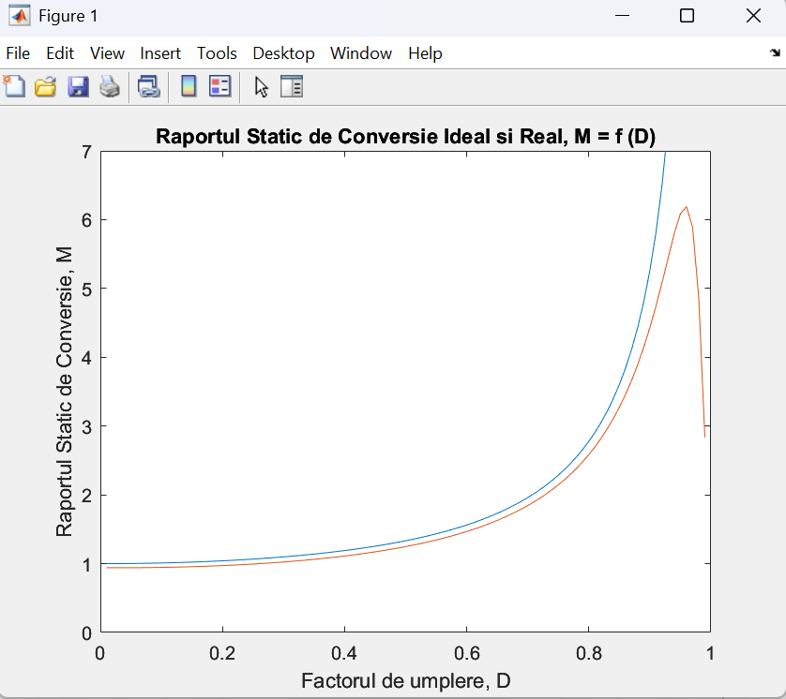
    - CUK cu izolare:
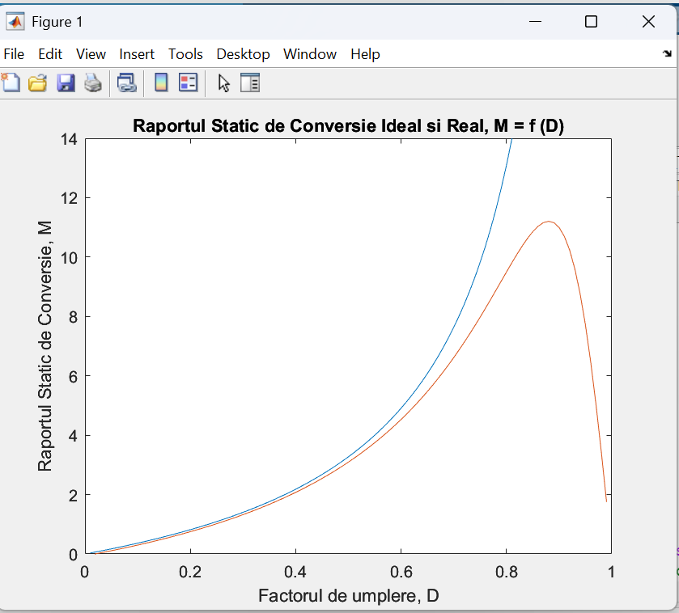
- Pierderile pe dispositive și dependența randamentului de factorul de umplere:
    - Convertor pătratic:
          - $IQrms=\sqrt{D}*IL1$
          - $ID2=\left(1-D\right)*IL1$
          - $ID3=D*IL2$
          - $ID4=\left(1-D\right)*\left(IL1-IL2\right)$
          - $IC2rms=\sqrt{D*IC2on^{2}+\left(1-D\right)*IC2off^{2}}$
          - $Vorms=\sqrt{D*Voon^{2}+\left(1-D\right)*Vooff^{2}}$
          - $Rp=R*\frac{RC2}{R+RC2}$
          - $PQ=IQrms^{2}*Ron=0.0894W$
          - $PD2=VD2*ID2=0.4663W$
          - $PD3=VD3*ID3=0.2337W$
          - $PD4=VD4*ID4=0.2337W$
          - $PC2=IC2rms^{2}*RC2=0.0017W$

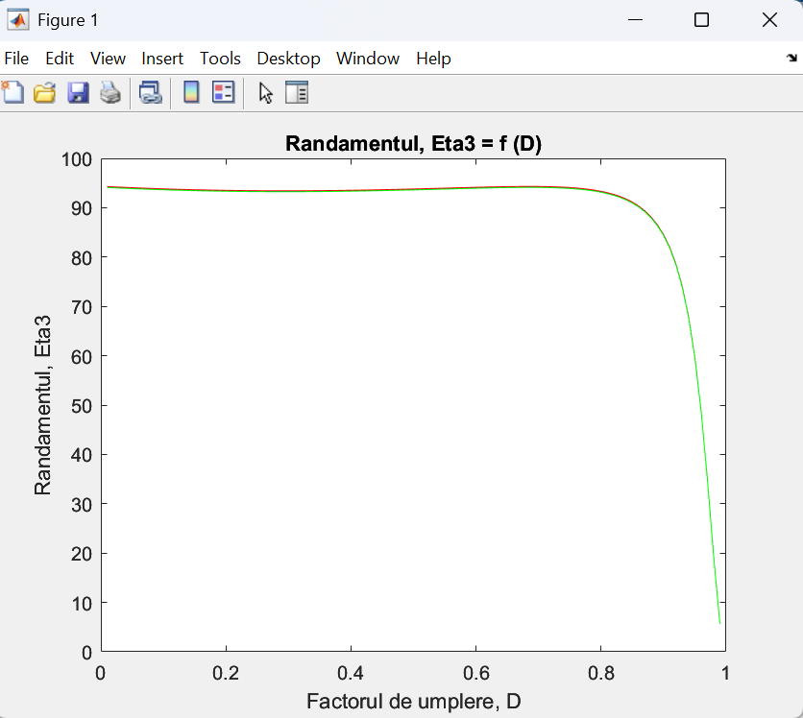
    - CUK cu izolare:
            - $Rp=R*\frac{RC2}{R+RC2}$
            - $IC2rms=\sqrt{D*IC2on^{2}+\left(1-D\right)*IC2off^{2}}$
            - $Vorms=\sqrt{D*Voon^{2}+\left(1-D\right)*Vooff^{2}}$
            - $IQrms=\sqrt{D}*$(IL1 + n*IL2)
            - $ID=\left(1-D\right)*\left(IL2+\frac{IL1}{n}\right)$
            - $PQ=IQrms^{2}*Ron$
            - $PD=VD*ID$
            - $PC2=IC2rms^{2}*RC2$

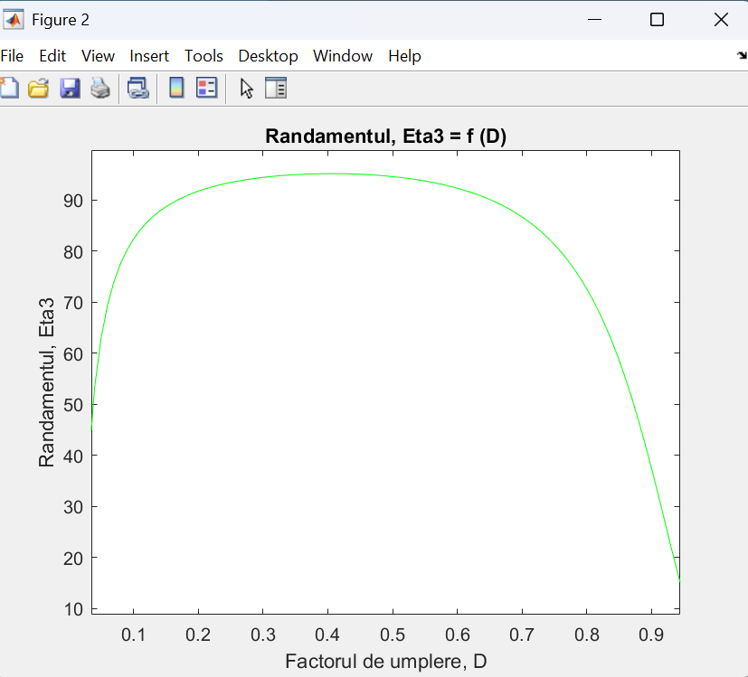

- Schema de comandă:

